**DAILY ONLINE ACTIVITIES SUMMARY**

|  |  |  |  |  |  |  |  |  |
| --- | --- | --- | --- | --- | --- | --- | --- | --- |
| **Date:** | **17/07/2020** | | | | | **Name:** | **Katira Krishna J** | |
| **Sem & Sec** | **8th A** | | | | | **USN:** | **4AL16CS045** | |
| **Online Test Summary** | | | | | | | | |
| **Subject** | | **-** | | | | | | |
| **Max. Marks** | | **-** | | **Score** | | | **-** | |
| **Certification Course Summary** | | | | | | | | |
| **Course** | **Data Science Tools** | | | | | | | |
| **Certificate Provider** | | | **Cognitiveclass.ai** | | **Duration** | | | **5 hours** |
| **Coding Challenges** | | | | | | | | |
| **Problem Statement: Python program to select the ith smallest element from a list in expected linear time.** | | | | | | | | |
| **Status: Completed** | | | | | | | | |
| **Uploaded the report in Github** | | | | | **Yes** | | | |
| **If yes Repository name** | | | | | **Krishna_Katira** | | | |
| **Uploaded the report in slack** | | | | | **Yes** | | | |

Online Test Details:

No test conducted

Certification Course Details:

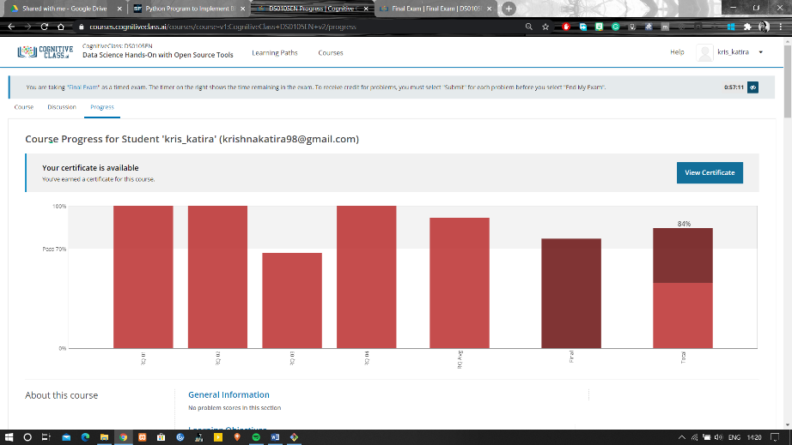

Coding Challenges Details:

**Program:**

def select(alist, start, end, i):

"""Find ith smallest element in alist[start... end-1]."""

if end - start <= 1:

return alist[start]

pivot = partition(alist, start, end)

# number of elements in alist[start... pivot]

k = pivot - start + 1

if i < k:

return select(alist, start, pivot, i)

elif i > k:

return select(alist, pivot + 1, end, i - k)

return alist[pivot]

def partition(alist, start, end):

pivot = alist[start]

i = start + 1

j = end - 1

while True:

while (i <= j and alist[i] <= pivot):

i = i + 1

while (i <= j and alist[j] >= pivot):

j = j - 1

if i <= j:

alist[i], alist[j] = alist[j], alist[i]

else:

alist[start], alist[j] = alist[j], alist[start]

return j

alist = input('Enter the list of numbers: ')

alist = alist.split()

alist = [int(x) for x in alist]

i = int(input('The ith smallest element will be found. Enter i: '))

ith_smallest_item = select(alist, 0, len(alist), i)

print('Result: {}.'.format(ith_smallest_item))